Digital Egypt Pioneers Initiative (DEPI)
This graduation project was developed and implemented by:
1- Mahmoud Abdel-Majeed Abdel-Hay
2- Ihab Yousry Abu El-Yazid
3- Hoda Ahmed Abdel-Moneim
4- Sara Abdullah Zakaria
5- Eman Mostafa Shehata
Under the Supervision of:
Mr. Ramez Barakat

📘 Dynamics 365 Finance & Operations – General Ledger Manual

Step 1: Create a New Legal Entity
Description: A legal entity represents a company with its own financial records.
Steps:
- Navigate to Organization Administration > Organizations > Legal entities.
- Click New.
- Enter Name, Company ID, Address, and Currency.
- Save and activate the entity.
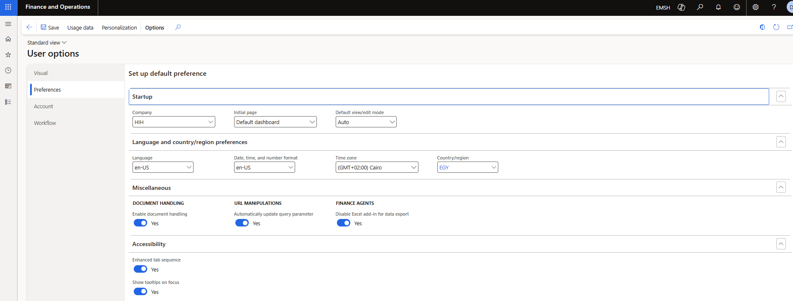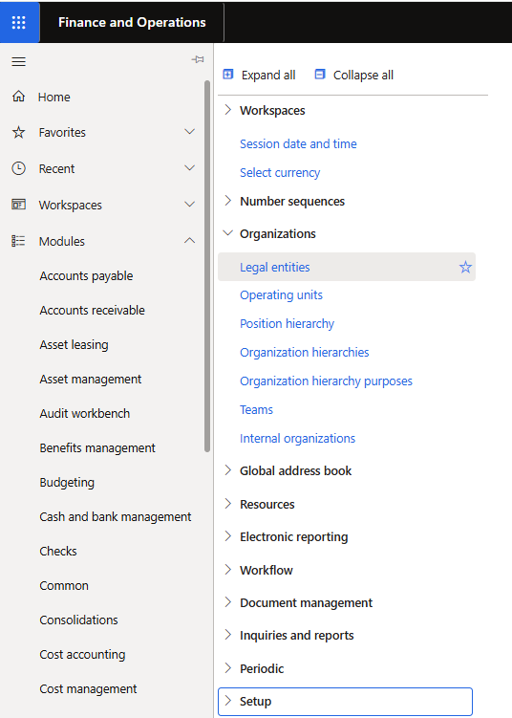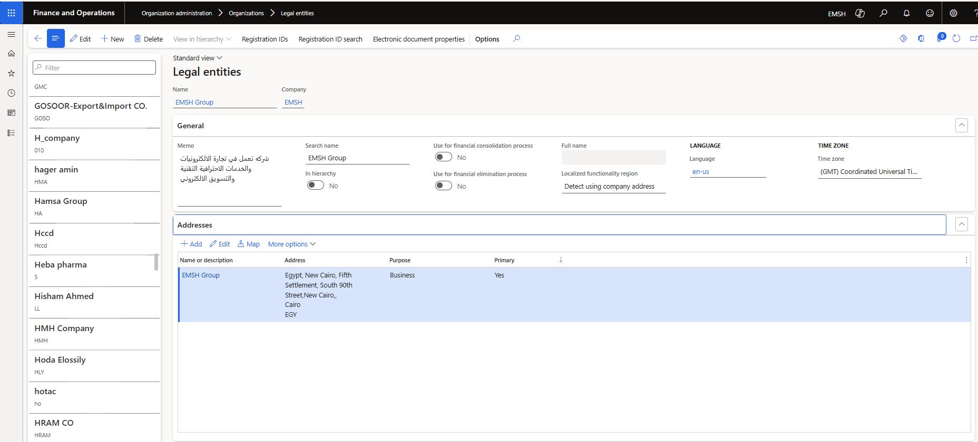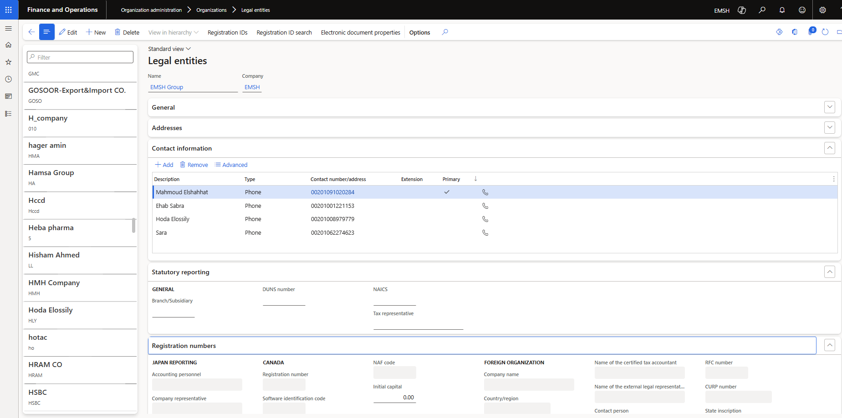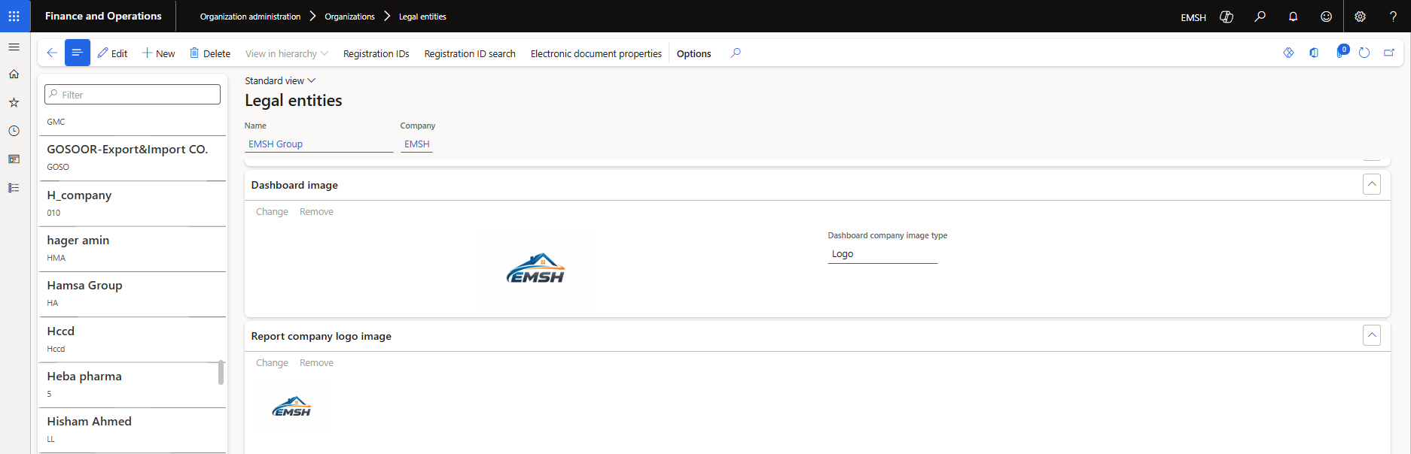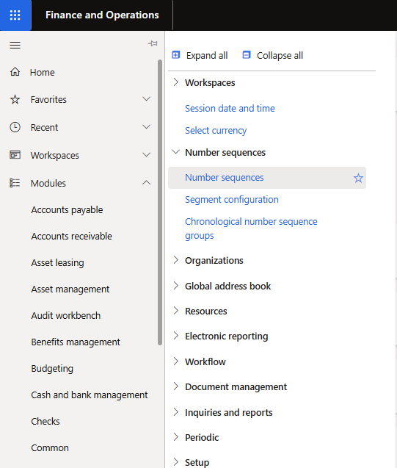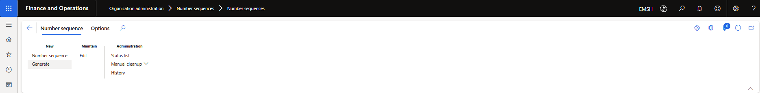

Step 2: Configure Chart of Accounts

Description: Defines the structure for recording financial transactions. Steps:
- Go to General Ledger > Chart of accounts > Accounts.
- Define Main accounts (Assets, Liabilities, Revenues, Expenses).
- Assign Account types and Posting layers.
- Save configuration.
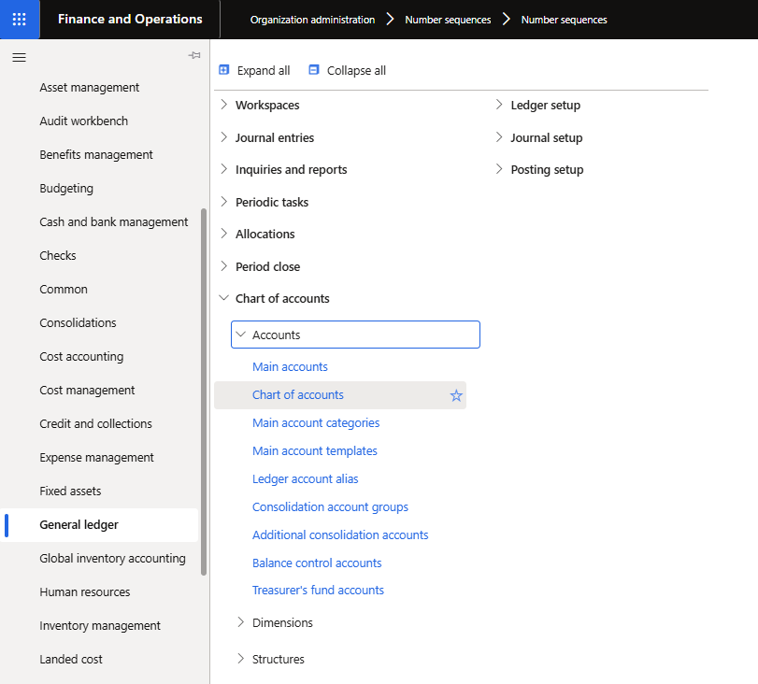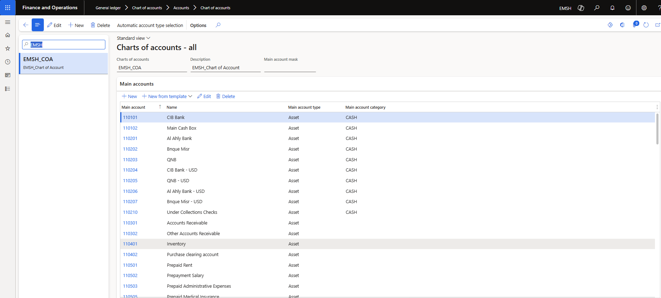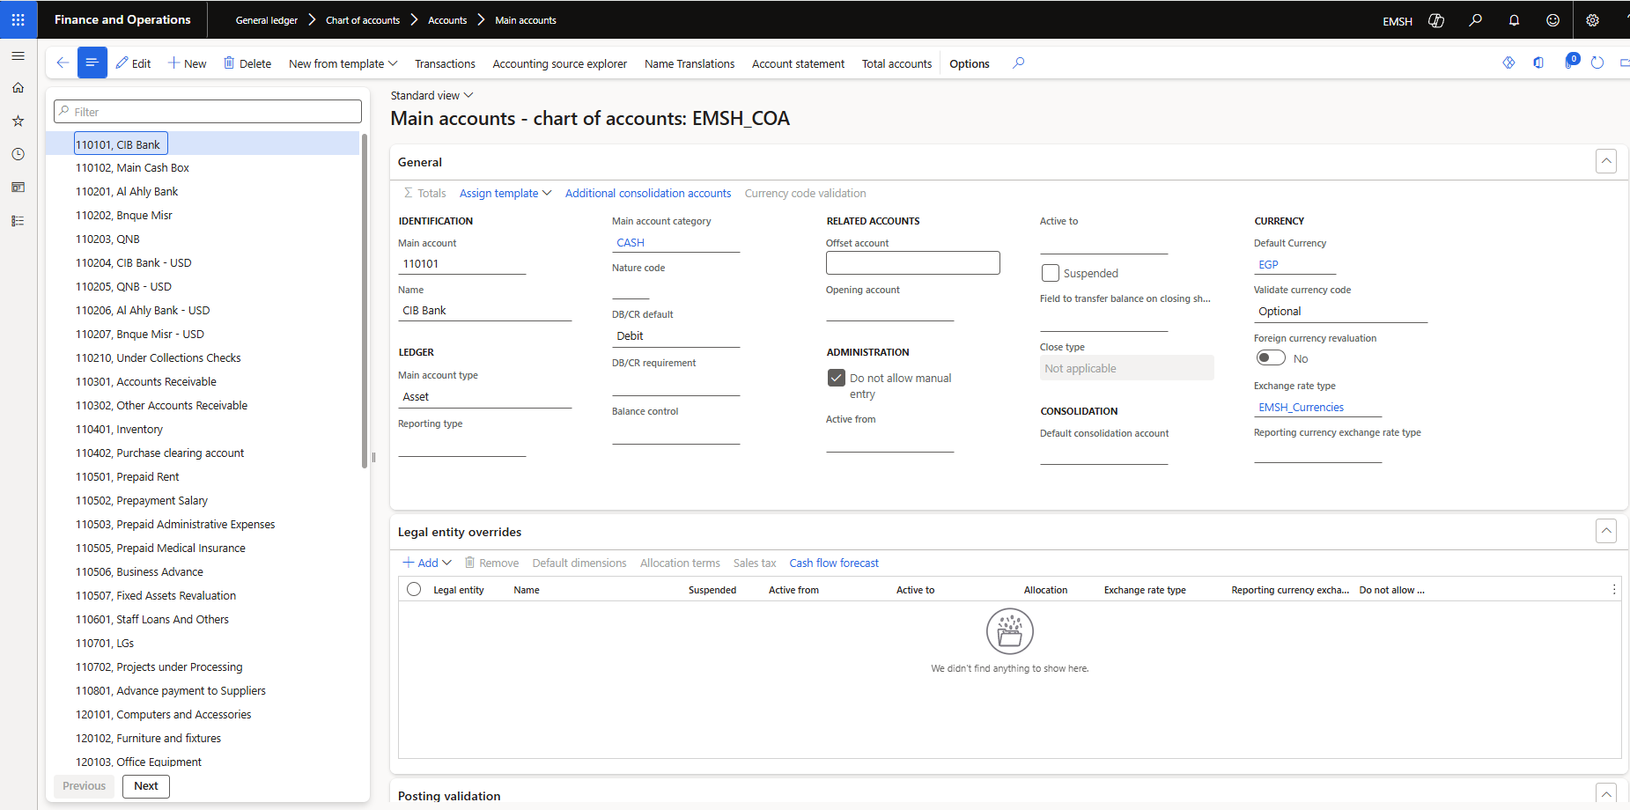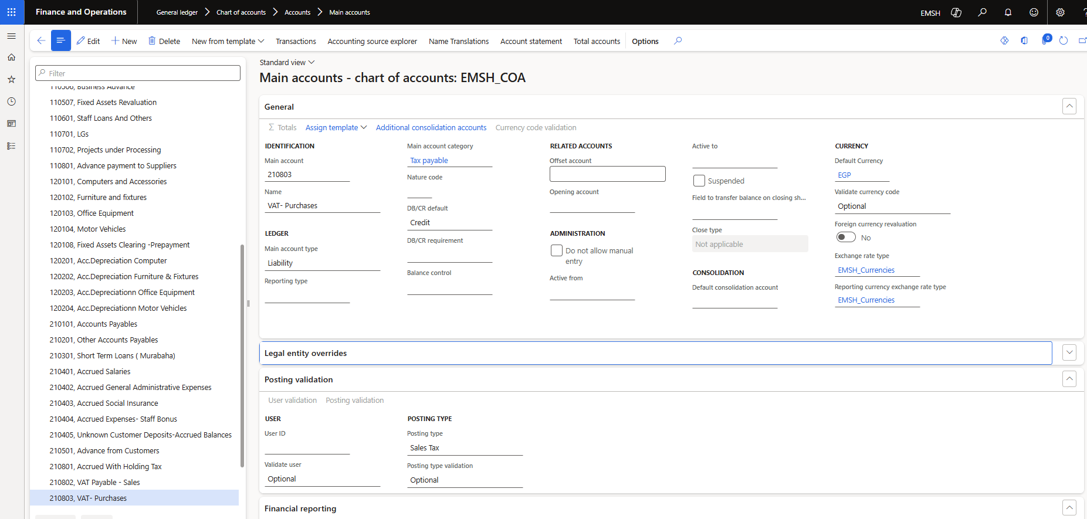

Step 3: Set Up Fiscal Calendar

Description: Fiscal calendars define reporting periods. Steps:
- Navigate to General Ledger > Ledger setup > Fiscal calendars.
- Create a new calendar and define Years and Periods.
- Assign the calendar to your legal entity.
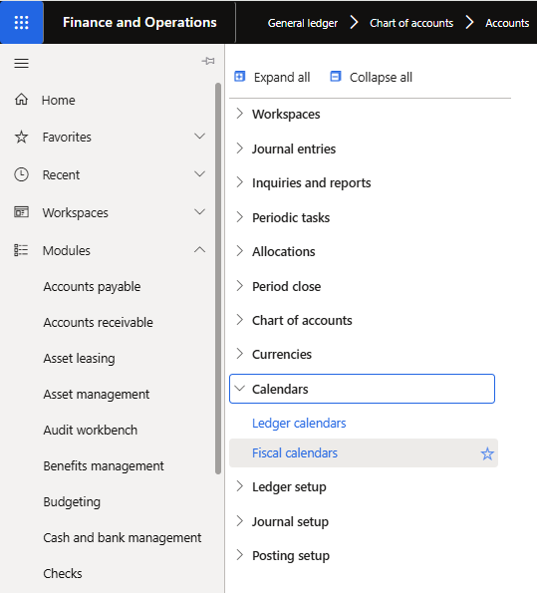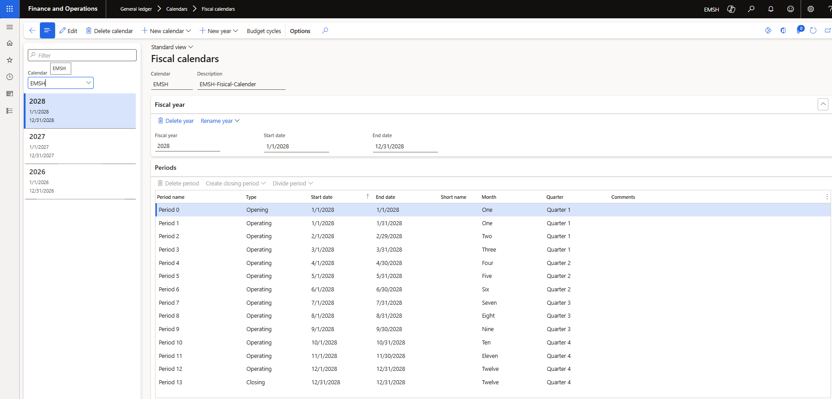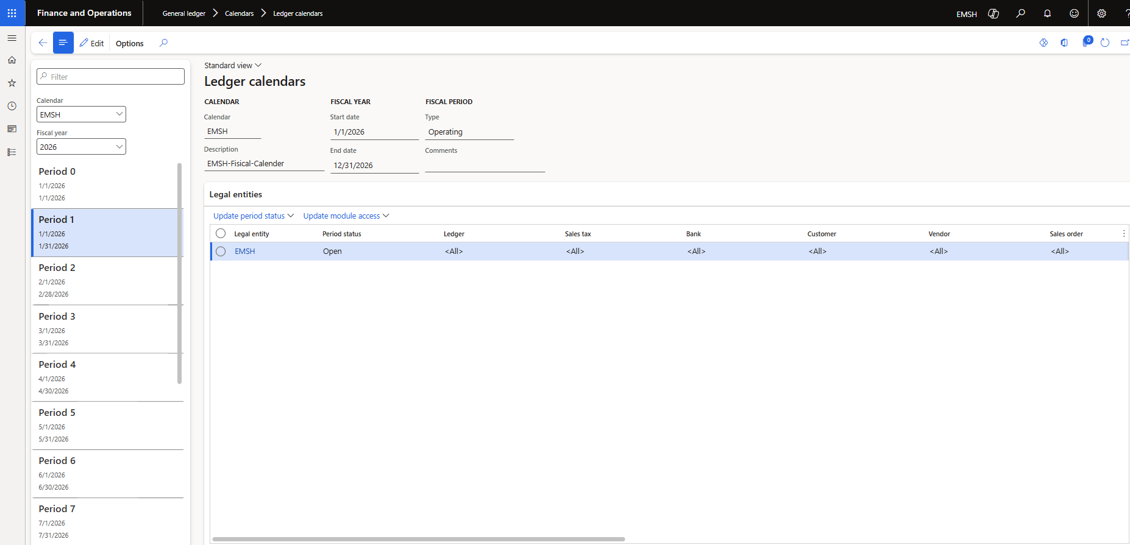
Step 4 (Extended): Configure Ledger, Journals, and Dimensions
Description: In addition to setting up the ledger and journals, you must prepare and activate financial dimensions. Dimensions allow you to track transactions by categories such as department, cost center, or project.
Steps:
- Define Financial Dimensions
  - Navigate to General Ledger > Dimensions > Financial dimensions.
  - Click New and create dimensions (e.g., Department, Cost Center, Project).
  - Assign names and descriptions for clarity.
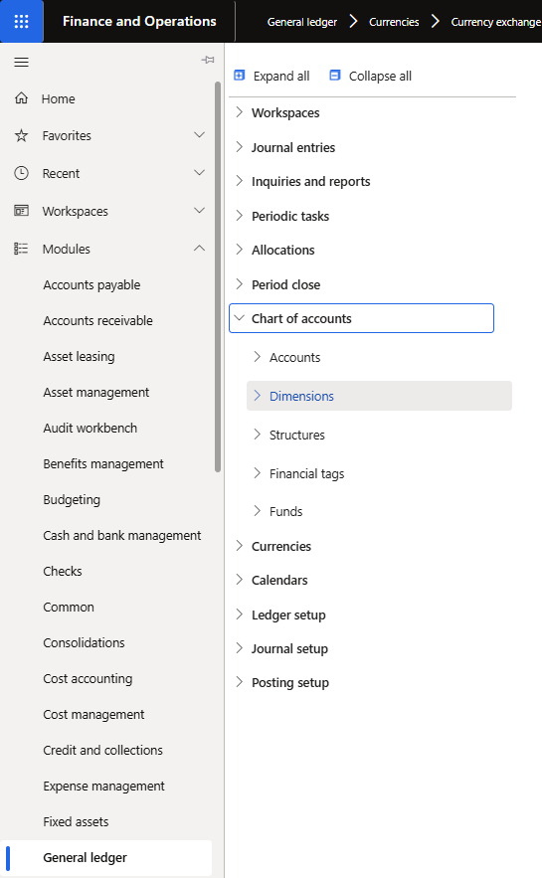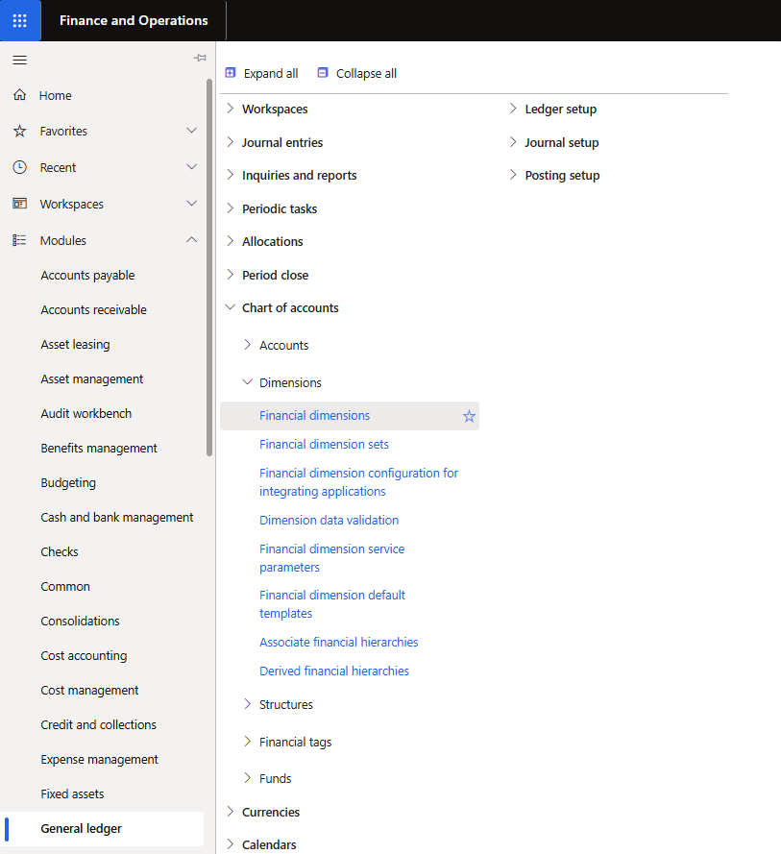
- Prepare Dimension Structures
  - Go to General Ledger > Dimensions > Dimension structures.
  - Create a new structure and add the required dimensions in the desired order.
  - Save the structure.
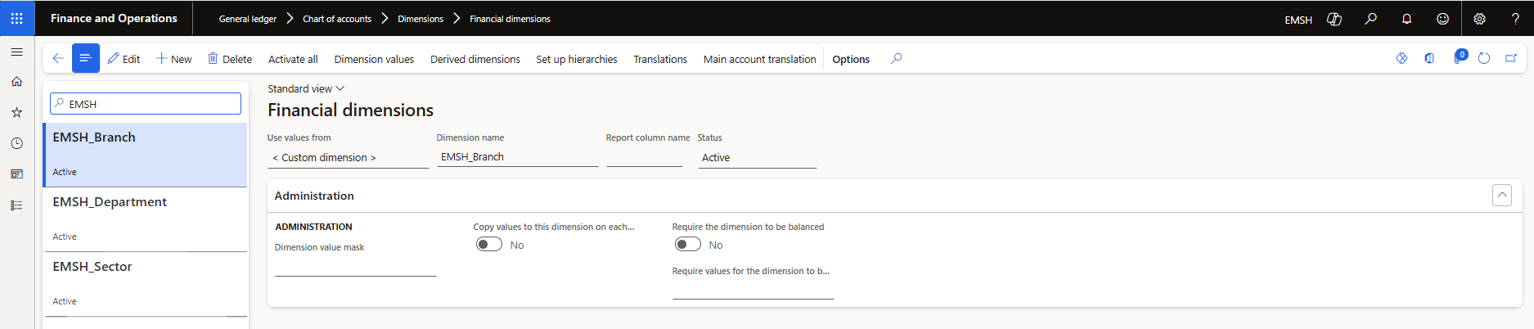
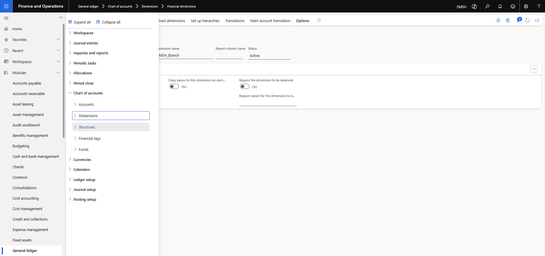
- Activate Dimension Structures
  - Select the structure you created.
  - Click Activate to make it available for use in transactions.
  - Ensure activation is successful before proceeding.
- Link Dimension Structure to Legal Entity
  - Navigate to General Ledger > Ledger setup > Ledger.
  - In the Ledger setup form, assign the activated dimension structure to the legal entity.
  - Save changes.

Step 5: Create Chart of Accounts Structure

Description: The Chart of Accounts structure defines how accounts and dimensions are combined for financial transactions. This ensures consistency in posting and reporting.
Steps:
- Navigate to Chart of Accounts Structure
  - Go to General ledger > Chart of accounts > Structures.
  - The list of existing structures will appear.
- Creating a New Structure
  - Click New.
  - Enter a Name and Description for the structure (e.g., “Main COA Structure”).
  - Add Main Accounts
  - Select the Main account dimension.
  - Define the account ranges (Assets, Liabilities, Revenues, Expenses).
  - Save changes.
(Insert Image: Adding Main Accounts)
- Add Financial Dimensions
  - Add other dimensions such as Department, Cost Center, Project.
  - Arrange them in the required order.
  - Save the structure.
- Activate the Structure
  - Select the structure you created.
  - Click Activate to make it available for use.
- Link Structure to Legal Entity
  - Navigate to General ledger > Ledger setup > Ledger.
  - Assign the activated Chart of Accounts structure to the legal entity.
  - Save changes.
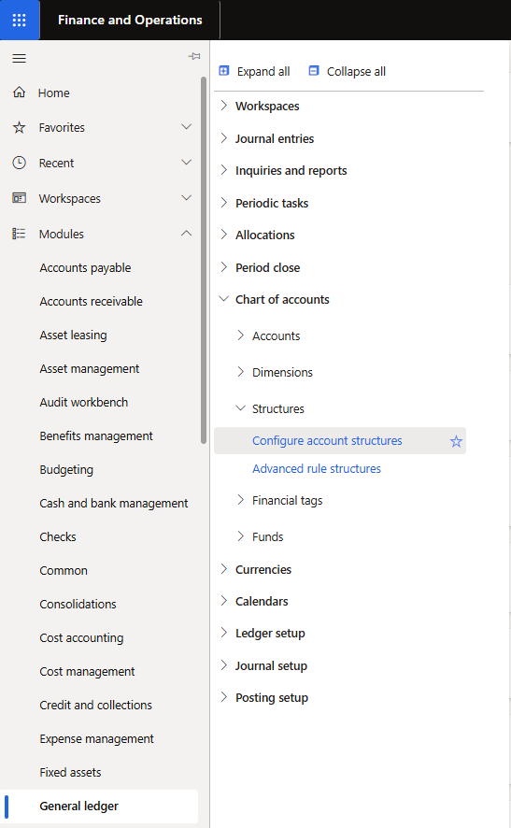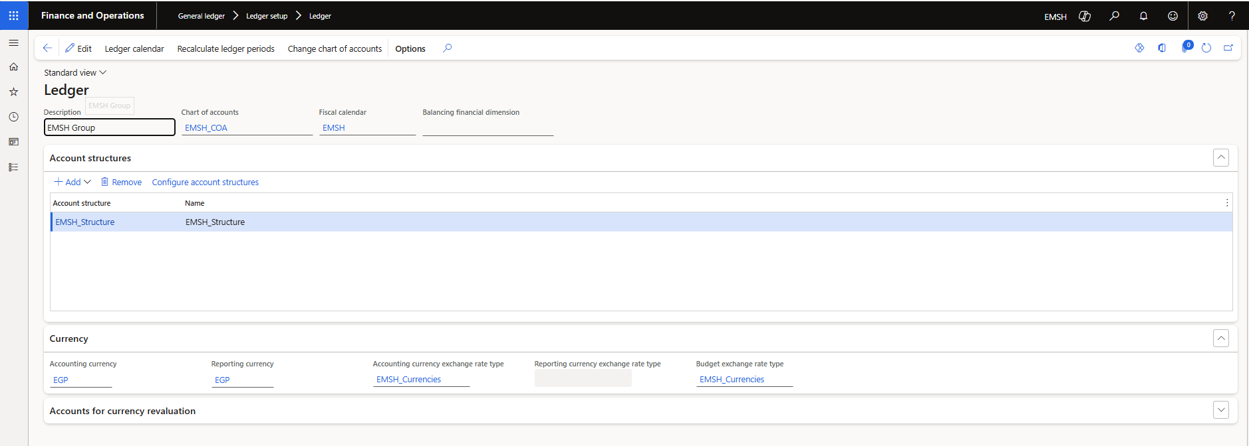

Step 6: Prepare Currency Exchange Rates
Description: Currency exchange rates allow the system to convert transactions from foreign currencies into the company’s reporting currency. Proper setup ensures accurate financial reporting and consolidation.
Steps:
- Define Currencies
  - Navigate to Organization Administration > Setup > Currencies.
  - Review the list of available currencies.
  - Add any additional currencies required for your legal entity.
- Set Up Exchange Rate Types
  - Go to General Ledger > Currency > Exchange rate types.
  - Create a new exchange rate type (e.g., “Daily”, “Monthly”, “Average”).
  - Assign a clear name and description.

- Exchange Rates
  - Navigate to General Ledger > Currency > Exchange rates.
  - Select the exchange rate type you created.
  - Enter the from currency, To currency, and the Rate.
  - Define the Valid from date to ensure the rate applies correctly.
- Activate Exchange Rates
  - Review the entered rates for accuracy.
  - Activate them so they can be used in transactions.
  - Ensure that rates cover all required periods.

- Link Exchange Rate Type to Legal Entity
  - Navigate to General Ledger > Ledger setup > Ledger.
  - In the Ledger form, assign the default exchange rate type to the legal entity.
  - Save changes.

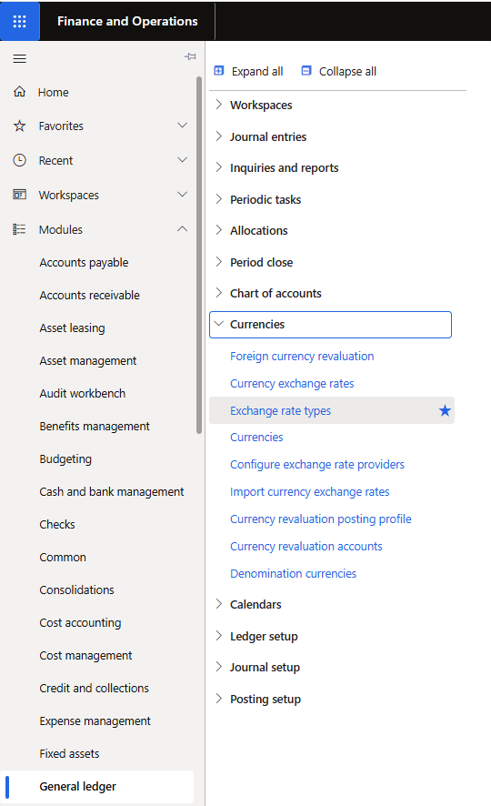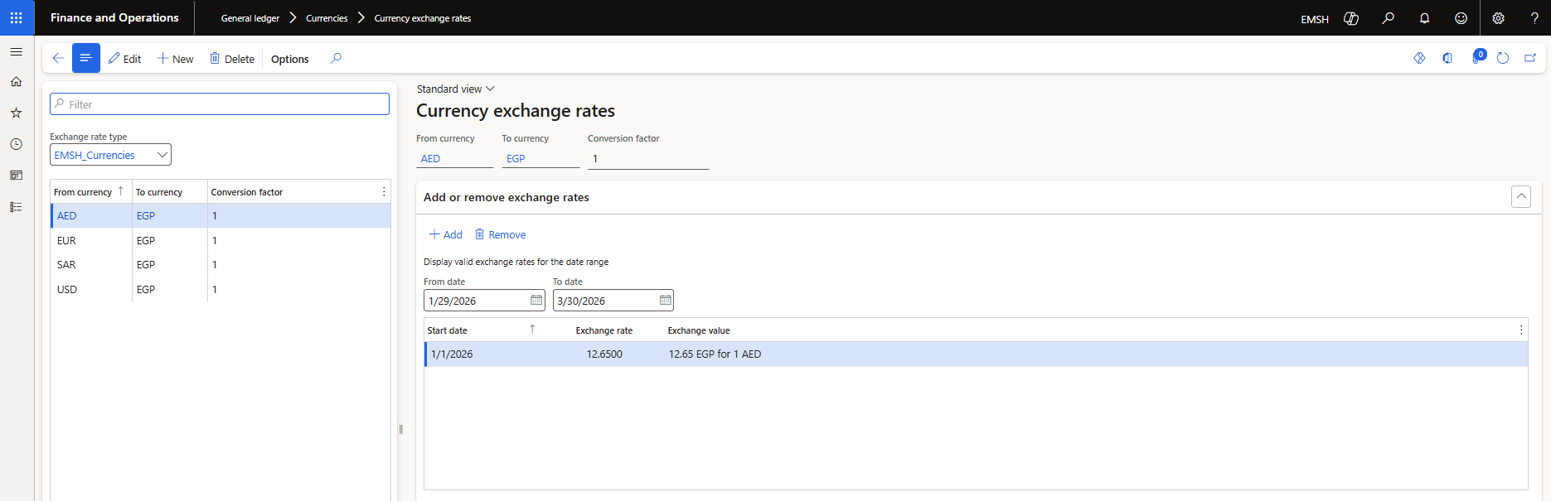

Step 5: Post Opening Balances
Description: Initializes the company’s financial position. Steps:
- Navigate to General Ledger > Journal entries > General journals.
- Create a new journal and enter Opening balances.
- Validate and post the journal.
Step 6: Record Daily Transactions
Description: Transactions include vendor invoices, customer payments, and expenses. Steps:
- Use General journals for manual entries.
- Integrate with Accounts Payable/Receivable for automated postings.
- Review and post journals.
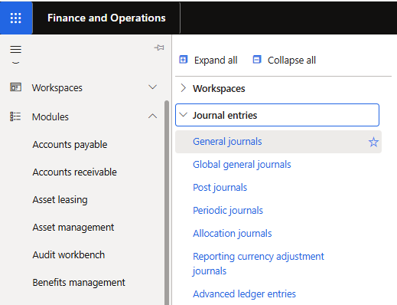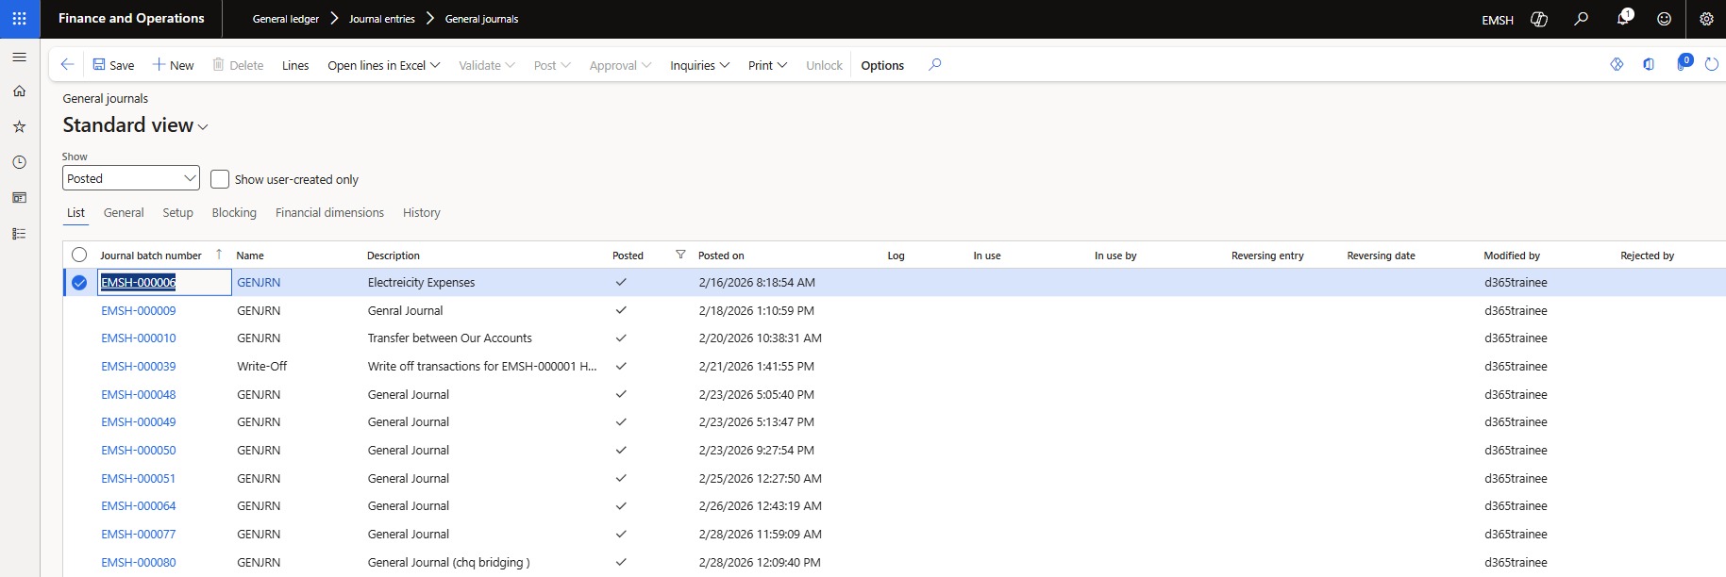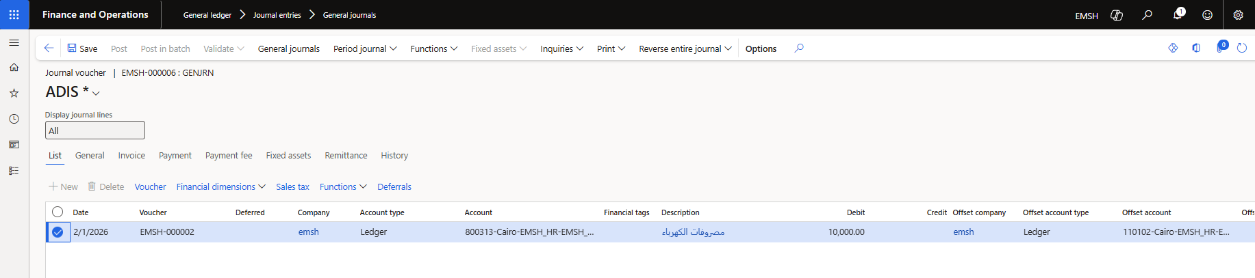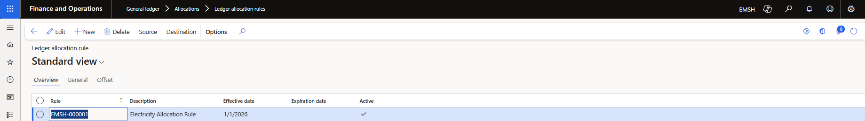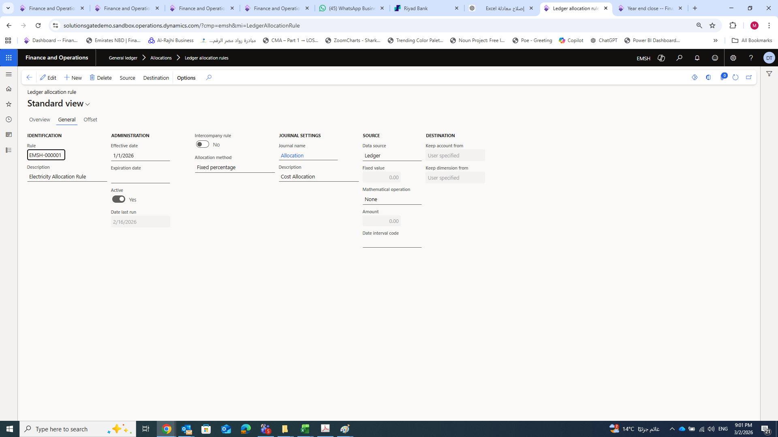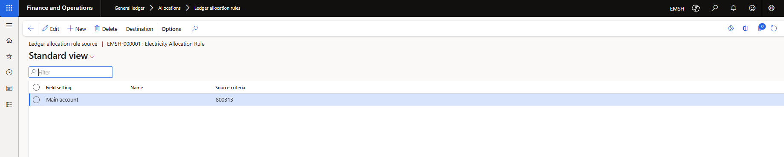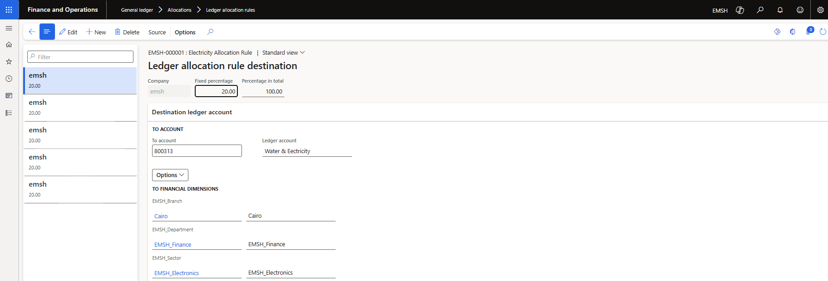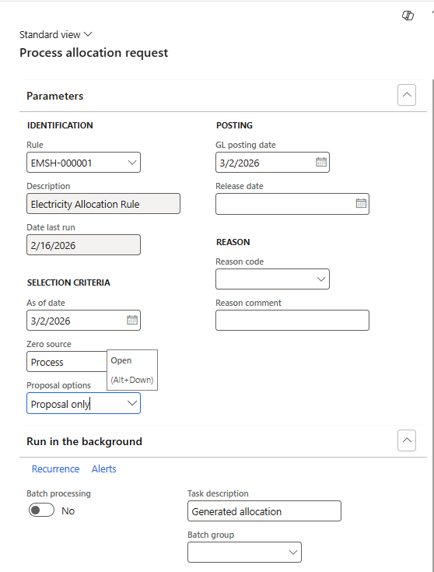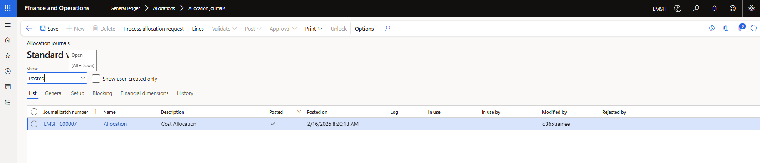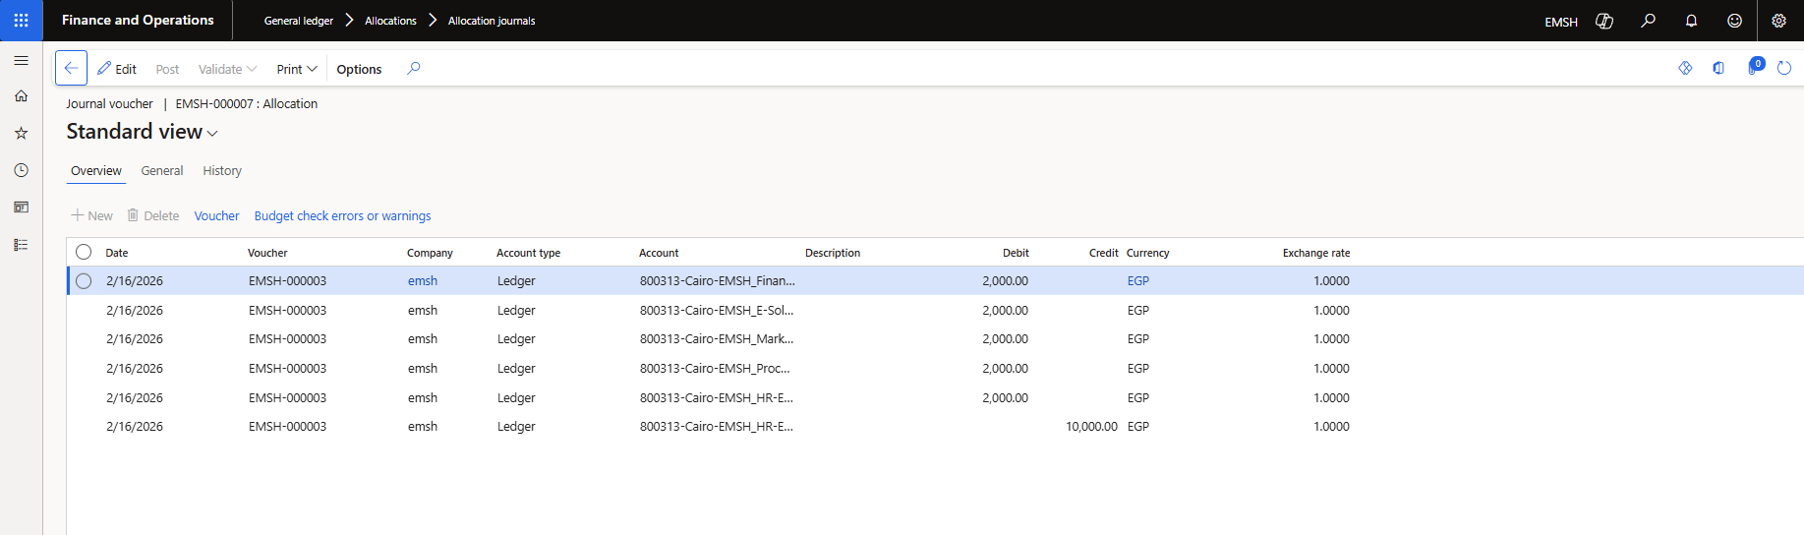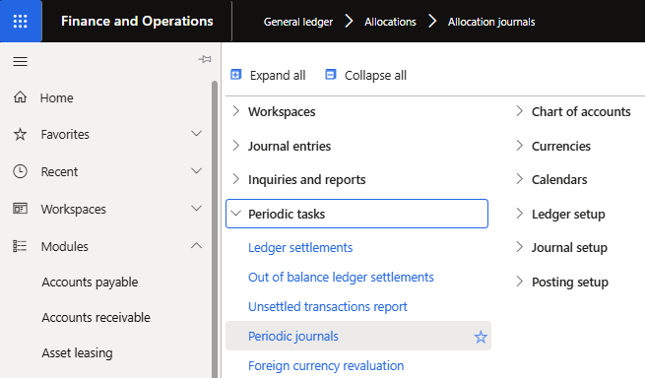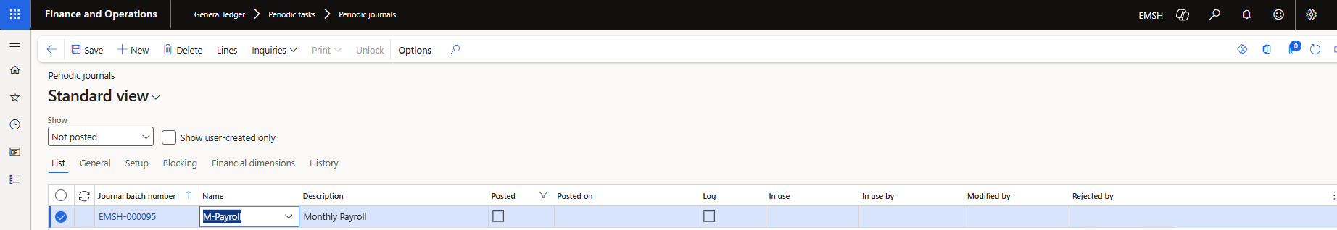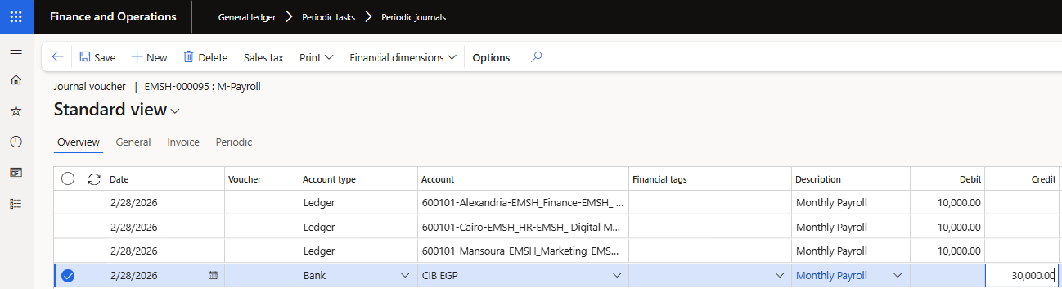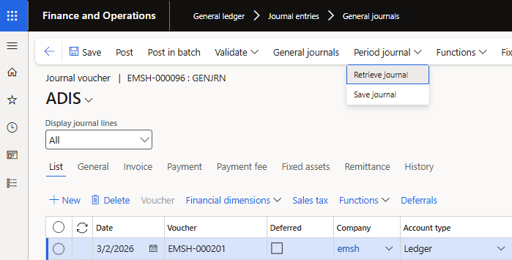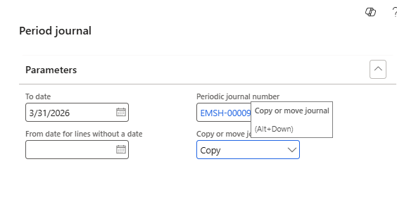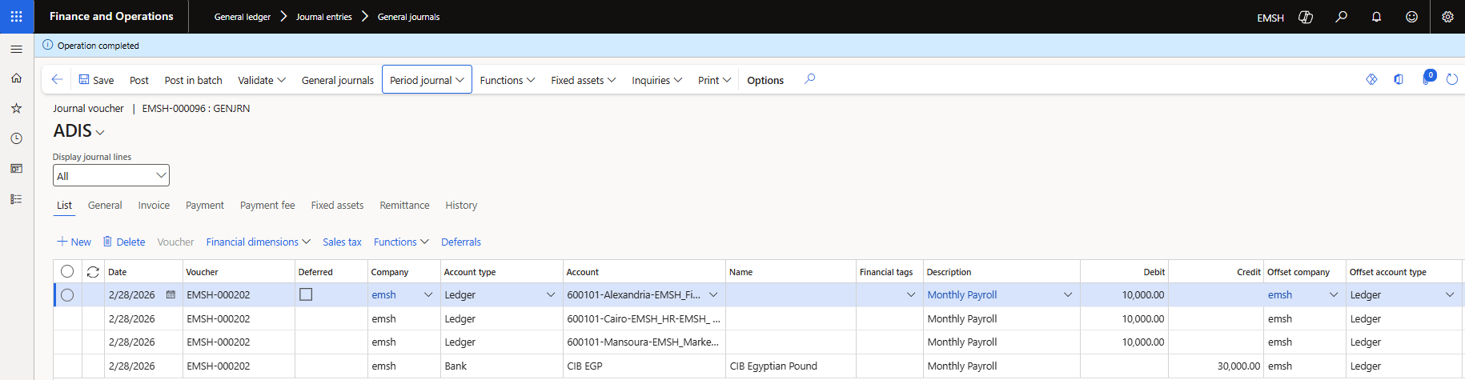
Step 7: Generate Financial Reports
Description: Reports provide insights into financial performance. Steps:
- Navigate to General Ledger > Inquiries and reports > Financial reports.
- Select report type (Trial Balance, Balance Sheet, Income Statement).
- Define parameters (date range, legal entity).
- Generate and export reports.
